An Exploration of the Use of Games in Virtual Worlds for Online Education

Authors: Martha García-Murillo and Ian MacInnes

Abstract

Advances in computing and telecommunications make it possible to take advantage of immersive electronic environments to deliver content. In this paper we present a policy game to be used in a virtual world. The benefits of this tool are examined using Gee’s learning principles. From this analysis we find that games in virtual worlds enable reflective exploration that helps participants to learn from their mistakes. Learning takes place from the content conveyed through the game and through the multimedia immersion that allows students to learn the nuances of these virtual contexts. Because there are no real world consequences, participants can take risks, provide or receive help from other students and, most importantly, apply this knowledge to a real world situation. Recommendations are provided to educators to help them exploit the great potential of games while being prepared for the obstacles that they will face.

Introduction

The purpose of this paper is to explore whether virtual worlds can provide a setting for a rewarding learning experience for college students. While online college education is a fairly common practice today, most distance interactions with students rely on relatively mature technologies such as course management systems (e.g., WebCT; Blackboard), message boards, electronic mail and weblogs (‘blogs’). These applications have facilitated the asynchronous interaction of individuals located in various places and time zones. However, information and communication technologies have advanced considerably, and college professors now have the opportunity to experiment with more innovative software applications that could make online interactions more engaging and stimulating. Virtual worlds represent one such application. In this paper we explore the pedagogical benefits of virtual worlds, which we describe here as graphically immersive, persistent, shared and typically avatar-based digital environments. We believe at the outset that virtual worlds offer instructors a potentially powerful tool for student learning and interaction through simulated experience.
The paper is divided in five main sections. The first section presents evidence from academic research of the potential benefits that virtual worlds can offer to distance students. Here we focus on video games and virtual worlds and the educational benefits that they can provide. The section also identifies the differences between virtual worlds and video games. The second section describes a lobbying game that was adapted from a traditional classroom to a virtual world environment. This was done because of the increasing popularity of online classes at university campuses. There is thus a need to find online activities that maintain the interest of students. Here we describe the simulation and the process that we followed to select a virtual world that could work with this simulation. The third section of the paper analyzes the educational value of the lobbying game within the virtual world. To do this we used Gee’s learning principles and determined if virtual worlds offer those benefits. The fourth section presents some of the challenges to educators of the process of developing games for virtual worlds. The fifth and last major section prior to the conclusions talks about future trends of virtual worlds in educational settings.

Video and Computer Games as Pedagogical Tools

Work, leisure and education have all been affected by advances in information and communication technologies. Technologies for entertainment purposes can be so captivating now that traditional classroom and electronic education programs sometimes pale in comparison. The video and computer game industry, in particular, has evolved radically over the past decade to offer interactive capabilities that were only imagined twenty years ago. The cutting-edge animation, opportunities for interaction, and dynamically generated narratives that can be found in today’s games have attracted large, diverse audiences, and many American teenagers and young adults play these computer games on a routine basis (Jayakanthan, 2002).
It is thus not surprising that aspects of our lives that were not initially affected by computer-based multimedia are now being transformed. Two such aspects that are being integrated and made increasingly less distinct are entertainment- and learning-related activities. Educational video games, for example, are now being designed around movie titles (Jayakanthan, 2002) and routinely played on home computers (Kerawalla & Crook, 2002). In contrast, computers at many schools are still being used heavily for word processing – an activity that students report finding less than stimulating (Mumtaz, 2001). Given the many mediated outlets that students now have, each one competing for the student’s attention, there is greater pressure on educators to be more creative in the delivery of instructional material.
The introduction of computer games in classrooms has aroused the interest of researchers across many fields, and as a result more papers are being published on the subject. Franklin, Peat and Lewis (2003) found that many computer games allow students to realize and react to the consequences of their (and their peers’) decisions. Subramanian, Khang and Sai (1999) found that computer games can diminish the apathy and boredom that affect many students. Heffler (2001) and De Vita (2001) argue that computer games can help instructors address differences in learning styles. According to Fleming and Rickwood (2001), video and computer games improve the moods of those who play them. His experiment showed that children who played violent video games experienced increased states of arousal more frequently than those who played pencil-and-paper games, but that their tendency towards violence did not increase. Fleming’s study suggests that video and computer games have the potential to lead to more satisfying learning experiences
These and other results should not be surprising given that video and computer games are widely perceived as vehicles for fun and play, and in such context an association with learning has the potential to increase a person’s understanding and retention of the material being taught. With their rich and immersive graphics, interactive capabilities, and users represented visually as avatars (i.e., graphic representations of users in virtual space), virtual worlds are similar to video and computer games in many ways, with a key difference being that the latter impose grand narratives and superseding goals while the former enable users to pursue their own goals and construct their own narratives. The constructivist paradigm that underlies virtual worlds makes them potentially more enriching for education experiences than traditional video games.
In the process of developing this chapter we needed to keep in mind that the focus of this book is on educational games situated in virtual worlds. In this context we need to think about formal education as a life long process. With the emergence of online education, more and more adults are returning to school to obtain higher degrees, to change careers, or simply to upgrade their skills. These are non-traditional students that already have work experience and their jobs impede them from participating in traditional classrooms. They are instead embracing the flexibility of online education. At the same time many of the professionals who have recently entered the work force are well versed with technologies and, as a result, educators have the opportunity to push the envelop and provide online experiences that challenge them and provide them with unique learning opportunities.

Virtual Worlds

Play is an activity that enhances children’s abilities by promoting exploration and experimentation. Children create imagined worlds in their play. As we grow older, though, our opportunities to explore and create imagined worlds are increasingly limited, and our creativity is curbed as a result (Harter, 1981). Virtual worlds offer an alternative space where educators can provide students the opportunity to explore and create. Because they may be perceived as entertainment, virtual worlds may be appealing to distance students as learning environments.
Virtual worlds provide great potential for every level of education, including post-secondary. There are countless examples of educational institutions that have already identified the potential of this means of learning. Ohio University (http://www.youtube.com/watch?v=aFuNFRie8wA), Harvard Law School (http://blogs.law.harvard.edu/cyberone/) and Case Western Reserve University (http://blogs.law.harvard.edu/cyberone/) for example all have campuses in Second Life (http://secondlife.com/). In these campuses classes are enhanced with multiple media to enrich the experiences of the online student population. These environments can allow off campus students to feel a closer connection to the university. Teachers and peers can enable experiences that may be difficult to replicate in the real world. For example, a psychiatry professor at the University of California Davis created a room where his students were able to see what patients with schizophrenia often see in their hallucinations (James, 2006).
Because of the versatility of virtual worlds educators need to realize that learning activities will require the development of games. This thus means that much preparation has to occur before the game can be ready for online classroom use. According to (Bartle, 1990), there are several elements that make a game. First it should have a set of rules. If the game entails competition then there should be a way of determining who wins. This can be done by specifying criteria or by identifying objectives to be met at the end. Because the purpose of an educational game is to teach a concept or a skill, the games should allow the participants to learn or practice whatever skills or knowledge is meant to be acquired.
Virtual worlds are often perceived to have a steep learning curve and this is a reason why relatively few educators have made use of virtual worlds. There are some notable exceptions, however. Kusunoki, Sugimoto and Hashizume (Kusunoki, Sugimoto, & Hashizume, 2000) have used a virtual world to teach urban planning and environmental concepts. At the Cornell Theory Center, researchers have developed a virtual world around the idea of a museum as a mechanism to teach science, languages and social studies in a more informal environment (Maher & Corbit, 2002). In the field of health care, researchers have used virtual environments to teach medical concepts (Mantovani, Castelnuovo, Gaggioli, & Riva, 2003).
In this paper we will use, Gee’s (Gee, 2003) ‘learning principles’ to show how virtual worlds can enhance learning. We will pair these learning principles to the virtual world to determine if there is pedagogical value in the use of these synthetic environments.

Sample Politics Game for a Virtual World

This paper is a synchronous role-playing simulation based on a game developed by Geoff Wong (Laver, 1979) [see appendix for instructions]. In this game in which each player assumes one of 12 roles (e.g., U.S. Senator, AT&T Vice President, Director of the Business Software Alliance) and tries to convince other players to vote in accordance with his or her role’s interests on one or more of three legislative bills. Players are instructed to employ any strategy at their disposal to accomplish this and hopefully those that are outline in the policy section of this paper. The use of actual bills makes it easier for instructors when students ask for more information about them. Our simulation made use of three bills that have recently been considered by one or more legislative bodies:
- SPY ACT (Securely Protect Yourself Against Cyber Trespass Act). If passed, SPY ACT would impose fines of up to $3 million against makers of software that steal personal information from a user’s computer or hijack a user’s browser.
- Digital Media Consumers’ Rights (DMCR) Bill. If passed, the DMCR Bill would (a) allow consumers to break copy controls to make personal copies of audio tracks or movies from discs (CDs, DVDs) they own, and (b) require all copy-protected CDs and DVDs to be labeled as such.
- Broadband Regulation and Modernization (BRM) Bill. If passed, the BRM Bill would prohibit a government or any entity it creates from offering broadband service for free.
Ideally, the students will begin the simulation knowing a great deal more about these bills than what is provided by these summaries. Two factors work against this ideal, though. First, instructions for playing are relatively long, even with the summaries, and would be made even longer with, say, an appendix detailing the bills’ specifications. Players of any game tend to find a thick stack of instructions daunting. Detail must always be balanced with “playability” and a reasonably shallow learning curve. Second, the chief pedagogical aim of the simulation is to teach lobbying concepts. If, in the process, students learn more about the bills used to demonstrate these concepts – and they most certainly will – then the simulation can be considered a success on multiple levels. However, depending on the course being taught, instructors may not have the time to teach students lobbying concepts and the history and particularities of the bills.
One of the most challenging aspects of designing this simulation is the need to establish a “level playing field” at the outset. In other words, at the start of each simulation, each bill should have, to the extent possible, an equal number of roles with explicit voting preferences supporting and opposing it. To run a simulation in which, say, eight players initially oppose a bill serves to disadvantage (and possibly discourage) the four players who favor it.
We created 12 roles that, to varying degrees and in various ways, had a stake in one, two or all three of the bills listed above. We chose to create 12 roles because believed that it would be difficult to coordinate the conversations and lobbying efforts of a larger group during the simulation. These roles included:
- The Governor of the state of New York;
- The Vice President of AOL/Time Warner;
- The Director of the Computer & Communications Industry Association (CCIA);
- The Vice President of AT&T;
- The Director of the New York Association of Cities and Towns (NYACT);
- The Director of the Business Software Alliance (BSA);
- The Director of the Electronic Frontier Foundation (EFF);
- The Chancellor of the State University of New York (SUNY);
- The Director of the American Marketing Association (AMA);
- The Director of the American Library Association (ALA);
- The Deputy Secretary of the U.S. Department of Higher Education; and
- A United States Senator from the state of New York.
A final and important design choice for this simulation is the decision to include or exclude explicit voting preferences for each role at the outset. In other words, instructors can opt to tell students how they (in their roles) intend, at least initially, to vote on each bill, or they can withhold this information and let the students decide this for themselves based on a brief statement of their role’s mission, which is provided to them by the instructor. As with the level of detail on selected bills, this decision may be influenced by time constraints, pedagogical objectives, and assumptions about students’ abilities and diligence.
One of our chief concerns in this game is that students may not take the time to conduct rudimentary research on their roles and, as a result, could ask us for additional information. Further, we speculated that knowing how one’s role initially stands on a bill might help students assume their roles more faithfully and, as a result, make them less inclined to play and vote according to personal preferences towards the bill.
Finally, if one opts, to tell students how their role initially stands on each bill, then it is essential to design the simulation such that each role has, at the outset, an explicitly undecided voting preference, or is said to be merely leaning in one direction, on at least one of the bills. It is hoped that this gives each player greater freedom to try to influence their fellow participants. In this simulation two of the roles– the Governor of New York and the U.S. Senator from New York – are designed as undecided on all three bills, perhaps causing these two roles to wield a disproportionately greater influence on voting outcomes.

Selecting a Virtual World

When working on the game we were inspired to design and conduct an avatar-based virtual simulation to offer students a stimulating alternative to the more conventional activities that are enacted in physical classrooms. We also wanted to break away from the traditional bulletin board discussions of online education. While these conventional modes have been shown to be pedagogically useful, we speculated that a simulation performed by avatars in a graphically rich online environment might possess a distinctive quality that is particularly appealing to undergraduate and graduate students. One of the authors had already designed and conducted a simulation for use in a physical classroom, so our tasks involved identifying a suitable virtual world and adapting the simulation for it.
We examined two virtual worlds: Second Life and Habbo Hotel. For our purposes, the power to create and modify an avatar and three-dimensional virtual environment using cutting-edge and relatively sophisticated design tools, though impressive, entails a steep learning curve for beginners. This concern, coupled with the required US$10 per person membership cost, which has since been waived, led us to consider Sulake Corporation’s Habbo Hotel, a virtual world designed for and marketed to teens. Sulake’s aim of profitably supporting affirmative online communities for paying teens, though beneficent, was not a factor in our decision to use Habbo Hotel. Instead, we wanted a virtual world that:
- Lets typical (non-expert) users easily create and use an expressive and visually appealing avatar;
- Makes it easy for users to communicate through and move their avatars;
- Provides private virtual space (such as a virtual room) in which members of a small group can interact comfortably and without interruption;
- Possesses a vibrant interface (or “look and feel”) that might appeal to undergraduate and graduate students; and
- Imposes no monetary costs on the students participating in the simulation.

Sulake’s revenues come chiefly from users who purchase Habbo credits to decorate the empty virtual rooms. As Figure 1 illustrates, we furnished the “lobbying room” with assorted rugs and chairs, a blue pinstriped floor, a potted palm tree and two whimsical plaques for the walls, all for US$20.

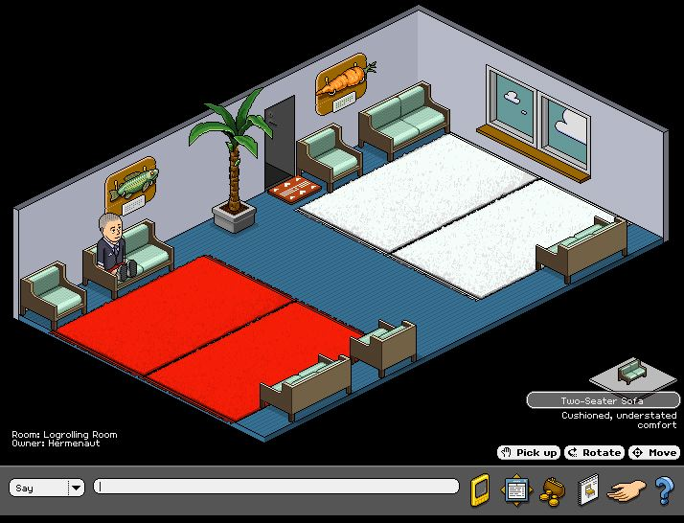

Figure 1: A screen capture of the “Logrolling Room” in Habbo Hotel. An author’s avatar sits pensively in one of the chairs.

Habbo Hotel satisfied our other conditions as well. All avatars look like cartoonish depictions of adults but some distinctiveness can be achieved through one’s selection of skin color, hair color and style, facial expression, and the style and color of one’s shirt, pants/skirt/shorts and shoes. Finally, the authors, each with limited experience in virtual worlds, found moving their avatars and navigating Habbo Hotel relatively simple and straightforward. Thus, despite being somewhat concerned about the reactions of college students to a virtual environment with a somewhat adolescent motif, the authors chose to use a specially designated room in Habbo Hotel as the space in which to conduct the simulation.

Educational Benefits of Games in Virtual Worlds

While it is clear that students have a lot more sources for entertainment and information this does not necessarily imply that games in virtual worlds would be beneficial for learning. To determine the effectiveness of games in these online environments this section presents an analysis of the learning principles that Gee (Gee, 2003) proposed in his book entitled What Video Games Have to Teach us About Learning and Literacy. Many of the 36 learning principles that Gee presents are, however, closely related and to simplify the presentation of the analysis with respect to games and virtual worlds the authors grouped these 36 principles into 8 larger categories.
When Gee wrote his book he was focusing primarily on video games and not necessarily on virtual worlds. The goal of this analysis is to determine if the learning principles that he proposed in the context of video games can also apply to virtual worlds. It is also important to realize that due to the fact that virtual worlds are not games per se, much of the learning that takes place comes from the games or simulations that the instructor prepares in advance for the students. In this paper we described an information policy simulation. Thus the analysis of Gee’s principles for this section is done here within the context of that simulation.

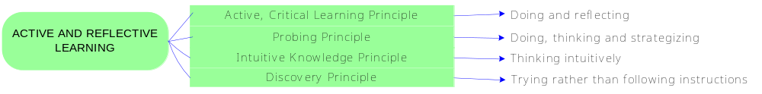

Active and Reflective Learning. The simulation was intended to teach students about the strategies that lobbyists of government officials commonly use to influence policy. In this case each student played the role of a different character and was asked to influence to vote in favor of their character’s interests. The simulation used the Habbo Hotel platform. The simulation required the students to identify the viewpoints of other characters and then try to influence them through conversation. The students have the opportunity to experiment with multiple strategies as they participate in the game. They have to discover the positions of those who do not share their views and then think critically about the arguments that they can use to convert them to their side. They can also experiment and strategize to make their influencing efforts more effective. This process of discovery and being actively engaged in the activity help them learn the complexities of the lobbying process first hand.

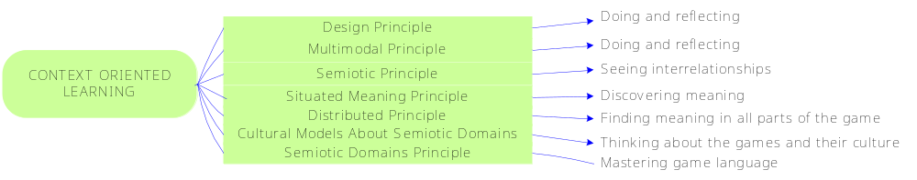

Context Oriented Learning. One of the major advantages of virtual worlds and games is the many opportunities that students have to learn from new environments and be able to adapt to new circumstances. A virtual world offers multiple opportunities for that. First every time that a person enters a virtual world they need to learn from the context itself, the design, other characters, and virtual artifacts. They also have the opportunity of learning from a variety of media such as graphics, text, sounds and even voice. From the context and the different media they need to find the meaning of these elements and the culture of this virtual world to determine norms of conduct. It is through careful observation that students learn these subtleties. In the context of the policy simulation the students need to determine whether it is better to shout, to speak, or to whisper a given comment. Some of these text speaking modes will be acceptable under certain circumstances while others will not. They need to determine if it is better to lobby a group of people at once or somebody alone. They need to determine how to initiate a conversation or how to join a conversation that has already started. All of these norms of conduct are each new opportunities for experimentation and learning. They can become more attuned to small subtleties in changes that happen in the environment that surrounds them or in the people that participate. This type of experience is difficult to emulate in the real world because it is not easy to move individuals to totally different contexts. This is even more challenging for online classes where it will be impossible to bring everyone to a single location. The more that students participate in this type of activity the more likely that their senses will be sharpened and they will be able to more easily adapt to many different types of circumstances. In the context of the policy simulation the students are putting themselves in a virtual world where they are experiencing real time interaction with their peers who are each playing roles. Their behavior in a synchronous environment will thus differ from the behavior that they are accustomed to from bulletin boards. In this setting they have to spend some time learning about the interests of the people that they need to lobby. They need to be able to identify them as each of the participants is represented in the virtual world as an avatar. Thus they need to observe all of the characters carefully to be able to identify the person that they want to influence. Much of the learning is not dictated but rather comes from participating in the game.

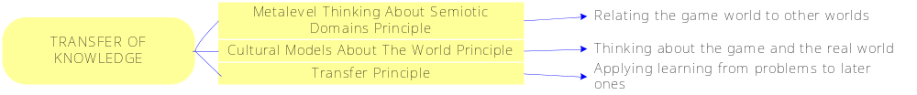

Transfer of Knowledge. While the students learn from the context and the characters that participate in the game the most important element of the game is the possibility of being able to transfer the knowledge that they learn from the virtual environment to real life situation. In the case of the policy simulation one of the objectives of the game is not necessarily to learn the skills of a lobbyist. It is true that part of the content that they need to learn for the information policy class is the different theories about influence but this type of information is not relevant to them unless they can find a way of applying it. Some fields have direct connections with policy while others are indirect. It will be easier for students in fields with stronger policy connections to apply what they learn.

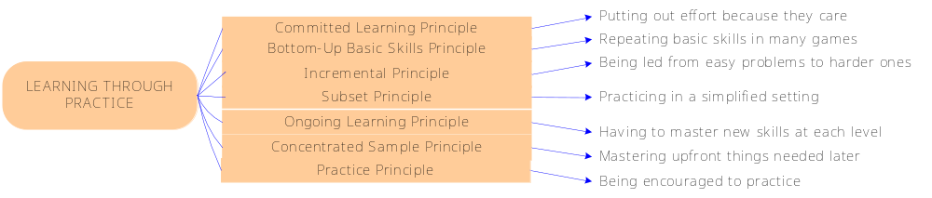

Learning through Practice. It is clear that many kids are highly skilled at playing video games. This happens because they have the opportunity to practice countless times which eventually improves their skills at whatever task they need to complete. Virtual worlds have the potential of providing this type of practice but it is much more limited within the context of a class because it will require the presence of other students. The possibility for practice will depend on how open the teacher wants to make the environment. In order to provide students with opportunities for practice there will need to be a critical mass of participants, all of whom know the instructions. While this could be possible within the context of a commercial virtual world it is less likely to be the case for an educational game. One of the things that educators should keep in mind when developing or modifying games for these virtual worlds is the graduated experience that the participant gets when playing the games. These games begin with simple tasks and then over time the tasks become more complex. It is for this reason that young people return again and again to play because they know that they can, with practice, reach a higher level. With a higher level there is also the reward of finding new things, new experiences, and new challenges. This should be taken into account when setting up a game for a virtual world. Easier tasks should come first and then adding modules or changing the rules to add more elements of greater complexity can potentially keep the students interested in the game to be enthusiastic about playing.
The lobbying simulation that was presented in this paper was not designed in this manner. It was set to be played once with a specific set of rules. The game could be modified to have, for example, a session where the lobbyists organize and then a session with potential policy makers. This can at least provide more than one opportunity to interact with the content of the class as well as providing two different experiences. Of the learning principles identified by Gee the ones related to practice are perhaps the most difficult to achieve within the context of a game in a virtual world.

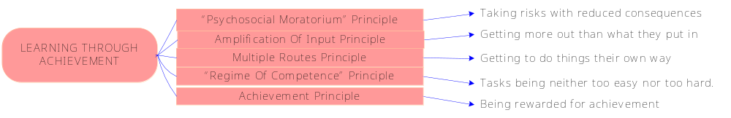

Learning through Achievement. People are limited in their tolerance of disappointment. It has been shown that most people react more positively to positive than to negative feedback. (McKeachie & Gibbs, 2002) Games have the power of providing players with the satisfaction of winning. While in a multi-player game someone will have to lose this is generally understood not as a failure but as an attempt. Young people are thus not discouraged and instead try a new strategy, taking risks. Given that failure in games does not translate into failure in real life the benefit of taking risks outweighs the costs of losing. It is precisely because of this that players have the opportunity of learning from the many attempts that they make in these worlds. The policy simulation in Habbo Hotel allows the students to try multiple strategies to try to influence their peers. They can use scare tactics, provide statistical information that supports their point, make deals to trade votes, or work with others who have similar interests to try to influence the policy issues at stake. If, for example, they failed to influence one person they may try a different technique the next time and, with trial and error, be able to determine the strategies that work best. Success in a simple, controlled, and fun environment keeps students interested in a task. Having achieved success in easier tasks motivates them to try more complicated ones. Educators, when developing games or simulations, should think about the opportunities that they offer students to achieve success to motivate them to take on more difficult content or skills.

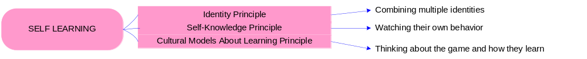
Self Learning. Virtual worlds provide opportunities for people to learn about themselves and about others. Educators have to keep in mind that virtual worlds are not bound by the laws of nature and they are not as bound by traditional social rules. With this in mind games for these worlds can be developed with great creativity and in a fantastic world. Depending on the subject matter educators can ask students to take on real or fictional characters for whom they will then take on different behavioral traits. In this process of assuming somebody else’s persona they can learn much about the circumstances that the person faces and the problems or benefits of having such a life. This can then give them an opportunity to compare the situation of this fictional character with their own life and learn from having or facing different circumstances. In the lobbying game the students are given the opportunity to be politicians, librarians, CEOs, presidents and in these roles they will then have to learn about each of these characters’ interests as well as the interests of others to be able to be effective at lobbying for their cause.
Evidence of the type of understanding that can take place between people when they take different characters is exemplified by Eric Brown and Asi Burak’s game Peacemaker which won the Public Diplomacy and Virtual Worlds competition organized by the University of Southern California’s Center on Public Diplomacy. In the game the participants take either Israeli or Palestinian characters and the objective is to make peace. This sort of simulation could involve roles such as a CEO, a youth counselor, or a terrorist. By taking somebody else’s identity, students can learn about content and context that in the past were only available in books. They can form opinions about a situation not from the detached and foreign context of books but from actually living the experience itself within a virtual world. These experiences also help them form their own views and learn about their own values and interests.



Content. The quality of content is critical for educators. While lectures and discussion boards in an online environment allow students to talk about an issue and reflect on the issue at hand, this knowledge can be superficial and likely to be forgotten. In a virtual world students are put in the middle of situations in a unique context. As a result, they are more likely to remember the issues illustrated given that they will inevitably have to make more effort in preparing and in testing many alternative actions. The mistakes they make and the successes they have will be remembered longer. Their reading now has a more concrete, even if fictional context. They can now decide the type of information that is more relevant for the situation. They are given the opportunity to select information on an as needed basis and take and relate information that is important for the type of activity that they are engaged in. This process thus allows for a much deeper level of knowledge.
The scope of topics that can be explored is nearly unlimited in Second Life. For example, people can develop businesses, pay for items with virtual world currency, and develop real state. Universities and other organizations can have a virtual presence. Virtual worlds are not limited by the physics and rules of the real world and thus can create more memorable situations. In addition, real world situations can be emulated in a virtual world. This flexibility of the medium can allow educators to convey a wide variety of information.
These activities are, however, time consuming to create, a major disincentive for educators. It is much easier to lecture for two hours on a subject than to develop a game, write clear instructions, see that students go to a virtual world and develop their characters, and then hope that the technology will work as expected. It is much more labor intensive for the same amount of knowledge conveyed. In the lobbying simulation, much preparation had to be done ahead of time and the students were required to participate in an orientation session before they were actually able to participate in the game. In order to minimize the amount of time necessary to play an educational game the instructor should try to think of several concepts that can be bundled together such that one effort is able to convey more knowledge. Alternatively one game can be built in a modular manner such as content experienced at various times in an incremental way. Bundling and gradualism are thus two important components for an effective delivery of content in a virtual world activity.


Social Learning. Prior to data networks video games were solitary and players interacted with the computer alone. With the advent of the Internet and the expansion of broadband, games have increasingly involved interaction among human players. Virtual worlds in their massively multiplayer form could not have existed without the Internet because the nature of the experience relies on the existence of other participants. Educators can take advantage of the social aspect of the game to foster collaboration. A game, although generally conceived as a zero sum experience, can be developed so that effective collaboration rather than direct competition leads to winning. In the lobbying game, social interaction is central to the success of the simulation. Communication allows the participants to practice their skills at influence. In this case winners of the game were those that were able to convert more individuals to get a bill to be voted in their favor. This type of game can create intellectual conflicts because a participant can be required to argue for and vote for a policy that he/she disapproves of.

Challenges for Educators Using Games in Virtual Worlds

While there are many potential rewards, as described in the previous section, there are also important challenges that educators need to keep in mind when developing games for virtual worlds. We were able to identify these challenges from the process of developing the lobbying game.
The first and greatest challenge is to develop the game itself. Most university faculty do not have formal training in education, much less game development. However educators should realize that in the Internet era it should not be difficult for them to find games designed for classroom use that could be adapted for a virtual world. This can substantially reduce the development time.
Second, while there are games already developed, these have not been archived in a single location and thus it will take some time and effort to find them.
Third, the adaptation process is still time consuming because detailed instructions need to be written for the students as a group as well as specific instructions for the participating characters. To make sure that the game works the professor should test the game a couple of times with a small group of students to find weaknesses before using it in a class.
Fourth, technology is unpredictable. Even in the process of developing the game without yet having it tested with students we experienced technological difficulties. In our case the authors could not enter the virtual world by mistake because one of us was entering the American site while the other had prepared the lobbying room from the English site. While this is a minor mistake other technical problems can easily happen, in particular regarding speed of connectivity and learning to navigate and function in a virtual world. To minimize the technical problems it will be desirable, as suggested before, that the professor familiarize the students with the virtual world before running the simulation.
Fifth, anonymity poses difficulties. In entertainment-based virtual worlds anonymity can lead to negative behaviors that, if present in an educational setting, can severely affect the dynamics of the game. In an anonymous environment the participant may take more risks but these can be undesirable risks from the perspective of others. Educators thus have to consider the behavioral standards that would be acceptable in the virtual world while the game is taking place. The teacher should consider when to reprimand and even expel a student who engages in inappropriate behavior. In all of these situations testing the game before using it in a class will help to minimize these challenges.

Future Trends

Virtual worlds are still new environments that are likely to evolve into complex settings that can provide rich and challenging experiences for students. Online distance education is based on the traditional campus education. However because it is no longer necessary to be physically present in a campus there is thus no need to have the student admitted to a particular university to be able to take a class. It is thus possible that in the future we could see models where students can develop their classes a la carte and be able to select from a variety of topics from different institutions and obtain a customized degree.
Virtual worlds could become the online classroom of the future in place of traditional bulletin boards. In these settings the professor can immerse the student in the context that relates to the content of the class. These experiential learning encounters can also be recorded and serve as reference and future learning for students that were unable to attend.
In virtual worlds distance does not matter and thus students can moved from one situation to another in a matter of seconds. Different topics covered in the curriculum could thus take place in multiple contexts. Students which were situated in a classroom alone or on a bulletin board alone could now be taken to multiple settings for many of the topics of the class.
With the popularity of educational games in virtual worlds open source efforts by faculty and students will help to develop more simulations. These worlds will allow developers to work together on the development of a simulated environment and learn in the process as well. In addition, because of these experiences, the learning curve that we experience today will be reduced because these setting will become second nature to students and extensive tutorials prior to games will not be necessary.
In virtual worlds students do not need to take only human personae but also any other organisms. Thus a student learning about zoology can become an insect for example and experience first hand the life of this organism. A chemistry student can become a molecule and once again see first hand how they interact with other elements.
In the context of life long learning students who are about to enter college can get to know what the life of a stock broker, or an archeologist, or a scientist is like. These simulations can move high school students from shadow career days that are difficult to coordinate and expensive to implement to virtual worlds where they can actually experience the careers that they are considering.
At the edges, one of the most exciting parts of virtual worlds can occur when the simulation is no longer a game and becomes a reality. Real world interactions and economic transactions take place. A class that started with a simulation and a role playing game can enter the real world through a virtual experience. Imagine, for example, a psychology student who is learning to become a therapist in a role playing game. He could initially have patients through role play but after gaining some experience they could provide counseling online to people who are unable to attend a therapy session in person. A student can thus learn in a controlled environment prior to encountering patients.

Conclusion

There are several lessons that can be learned from games in virtual worlds. First it is clear that the medium provides students many opportunities to learn about themselves through taking on multiple personae or even other entities. They can learn from participating in many contexts, each of which can provide different content. A multimedia environment in a digitally literate society can help to enrich the experience making the learning much more immersive and compelling. The social interactions can also support learning by allowing collaborations.
These virtual worlds will become the online education of the future because of the flexibility and the richness that educational games can provide students. At this point in time however there are important challenges to overcome. These can be attributed to the fact that we are just beginning to utilize this medium for distance education and we do not yet have the tools and the skills to develop games and work with students. Even though students today are more technologically sophisticated most have not yet been exposed to this type of experience. Thus the learning curve for them is still steep.
Few faculty members are sufficiently aware of these simulated environments and thus few resources have been provided to facilitate this type of education. However, the increasing popularity of these worlds and the presence of some universities and companies inside them will create the critical mass necessary to make development of the environment much easier, such as the creation of libraries that collect virtual world games and simulations for the many disciplines that are taught today in our campuses. The physical worlds will no longer dictate the rules of the virtual worlds and over time a completely different educational experience can become the distance education of the future.

References

Key Terms and Their Definitions

Distance education: A learning environment for students that take classes primarily on line from different locations “Teaching and learning in which learning normally occurs in a different place from teaching.” (http://www1.worldbank.org/disted/glossary.html).
Course management systems: Software applications designed to facilitate online education using a web interface. The system can manage enrollment, content, and grades among other things.
Lifelong education: The process of continued learning after an individual leaves formal education. This can include college continuing education courses, correspondence, and certifications in physical or distance format.
Video Game: Entertainment software with predetermined goals that can be played through specialized equipment or with a computer.
Virtual World: A graphically immersive, persistent, shared, and typically avatar-based digital environment that is generally hosted on servers connected to the Internet.
Avatar: A graphical image that represents a user in a virtual world.
Simulation: A simplified model that attempts to represent a situation that the creator intends.
Role playing game: A game where the participants take a real or fictional persona for entertainment or education.

The authors acknowledge the support of Joe Rubleske, who helped in the selection of the virtual world and designed the roles and the room that for the policy game.
We invented a body that we named the New York Association of Cities and Towns in order to have a role that represents local interests.

